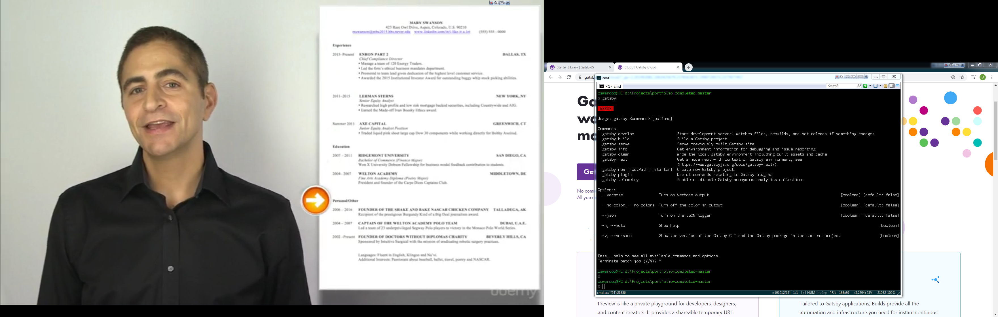

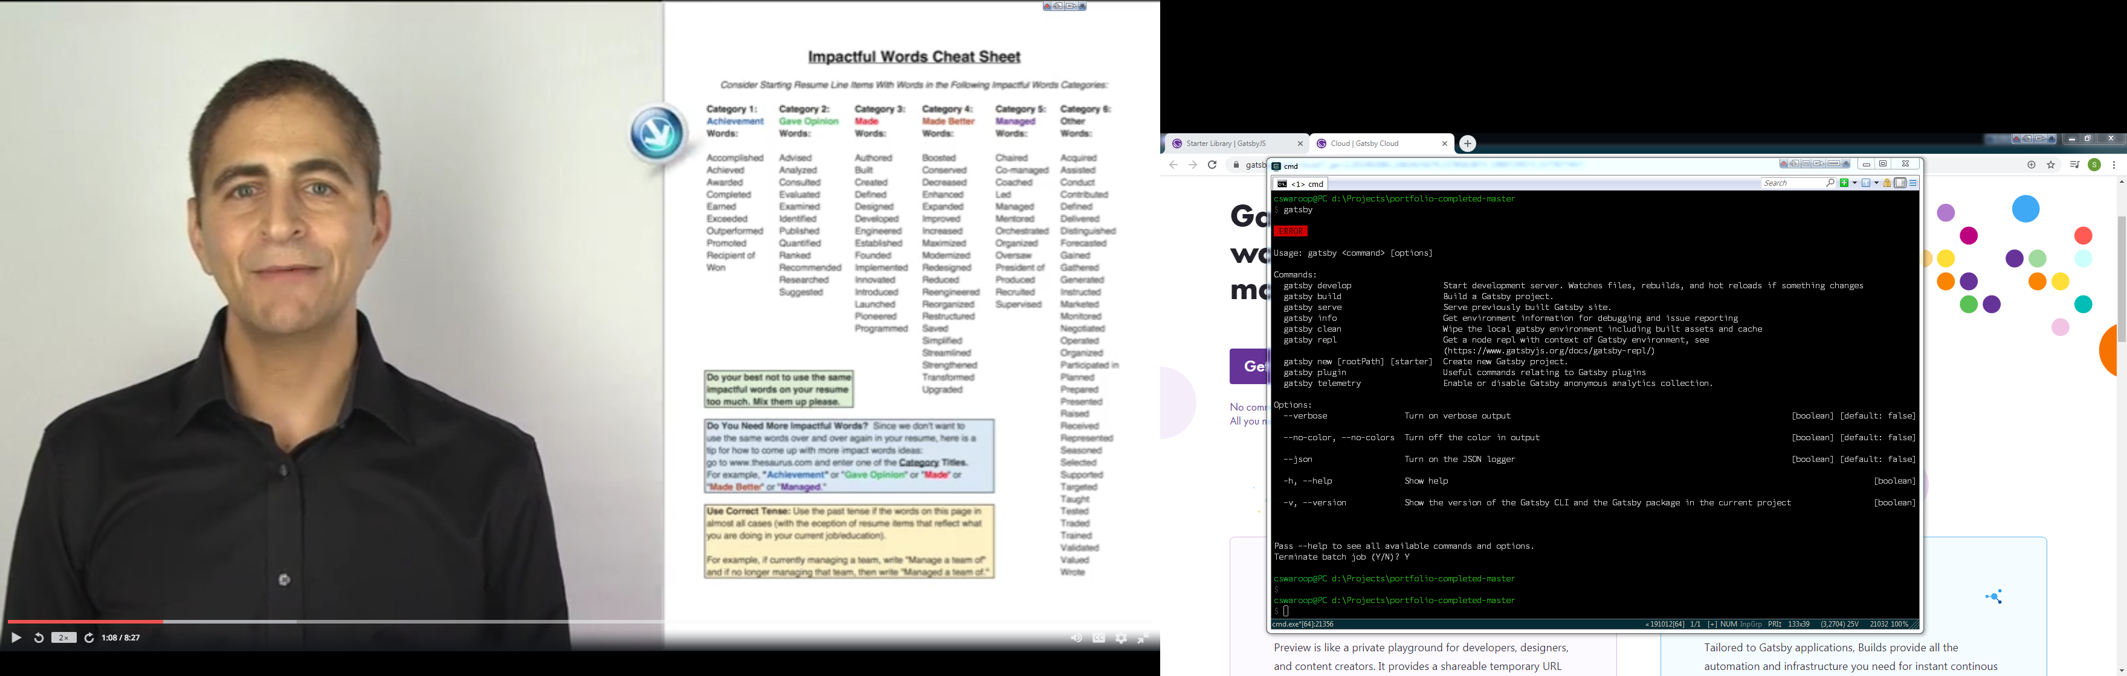

Swaroop Chalasani works as a CTO for Wisdom Kingdom Software Solutions. He has more than 10 years of experience in architecting and developing complex software solutions for Banks and Financial Services. Now, he leads the company's data science branch. His team delivers practical machine learning applications to businesses across the world. Their solutions cover an extensive list of topics, such as sales forecasting and warehouse planning, natural language processing (NLP) for IT support centers, algorithmic marketing, and predictive IT operations. Swaroop is a happy father of two boys. He loves learning all things new, reading books, and writing articles for top Medium publications.

|  |
| --- |
| **State of Clojure Community 2020** |

This annual survey collects and publishes information on the Clojure and ClojureScript

community. All results are made available to the public. Survey ends January 23rd.  
  
This survey consists of 5 pages:  
  
1. General info

2. Tool usage  
3. Clojure-specific questions (skip if not relevant)  
4. ClojureScript-specific questions (skip if not relevant)  
5. Final comments  
  
Please skip any questions that don't apply (only the first two questions are required). Contact clojure@cognitect.com with any questions or comments.

Top of Form

**Question Title**

**\*1. Which dialects of Clojure do you use?**

Clojure

ClojureScript

ClojureCLR

**Question Title**

**\*2. How would you characterize your use of Clojure, ClojureScript, or ClojureCLR today?**

I use it at work

I use it for serious "hobby" projects

I'm just tinkering

I use it for my studies

**Question Title**

**3. Prior to using Clojure, ClojureScript, or ClojureCLR, what was your primary development language?**

C or C++

C#

Common Lisp

Erlang

Go

Groovy

Haskell

Java

JavaЅcript

Kotlin

None

Perl

PHP

Python

R

Ruby

Scala

Scheme or Racket

Swift or Objective-C

Other / Too Many

**Question Title**

**4. How many years have you been programming professionally?**

0-5 years

6-10 years

11-15 years

16-20 years

21-25 years

25+ years

**Question Title**

**5. In which domains are you applying Clojure, ClojureScript, or ClojureCLR?**

Open source projects

Web development

Mobile app development (non-web)

Math / data analysis

Building and delivering commercial services

"Big Data"

Network programming

System administration / dev ops

Enterprise apps

Desktop apps (JavaFX / Swing / SWT / etc)

Graphics / Art

Music

Games

AI / NLP / machine learning

IoT / home automation / physical computing

Scientific computing / simulations / data visualization

Other (please specify)

**Question Title**

**6. The people that use the applications I build in Clojure, ClojureScript, or ClojureCLR are primarily...**

Outside my organization

Outside my team, but inside my organization

Inside my team

Just me

**Question Title**

**7. What is your organization size?**

1-10

11-100

101-1000

1000+

**Question Title**

**8. How many people at your organization use Clojure?**

1-10

11-40

41-100

100+

**Question Title**

**9. What primary industry do you develop for?**

Academic

Agriculture

Automotive or manufacturing

Communications / Networking

Consumer software

Education

Energy or utility

Enterprise software

Entertainment

Financial services / FinTech

Government / Military

Healthcare

IT/Cloud Provider

Media / Advertising

Retail / ecommerce

Scientific

Telecom

Legal

Other (please specify)

**Question Title**

**10. Where do you deploy Clojure, ClojureScript, or ClojureCLR applications?**

Use on local machine(s)

Traditional infrastructure

Private cloud (or hybrid)

Public cloud

**Question Title**

**11. How long have you been using Clojure, ClojureScript, or ClojureCLR?**

Less than a year

1 Year

2 Years

3 Years

4 Years

5 Years

6+ Years

I've stopped using it

**Question Title**

**12. How important have each of these aspects of Clojure, ClojureScript, or ClojureCLR been to you and your projects?**

|  | Not important | Important | Very important |
| --- | --- | --- | --- |
| Functional programming | Functional programming Not important | Functional programming Important | Functional programming Very important |
| The REPL | The REPL Not important | The REPL Important | The REPL Very important |
| Immutability | Immutability Not important | Immutability Important | Immutability Very important |
| Ease of development | Ease of development Not important | Ease of development Important | Ease of development Very important |
| Host (JVM/JS/CLR) compatibility / interop | Host (JVM/JS/CLR) compatibility / interop Not important | Host (JVM/JS/CLR) compatibility / interop Important | Host (JVM/JS/CLR) compatibility / interop Very important |
| Macros and expressive syntax | Macros and expressive syntax Not important | Macros and expressive syntax Important | Macros and expressive syntax Very important |
| Community | Community Not important | Community Important | Community Very important |
| Concurrency facilities | Concurrency facilities Not important | Concurrency facilities Important | Concurrency facilities Very important |
| Runtime performance | Runtime performance Not important | Runtime performance Important | Runtime performance Very important |
| Shared language between server and client | Shared language between server and client Not important | Shared language between server and client Important | Shared language between server and client Very important |
| spec | spec Not important | spec Important | spec Very important |

**Question Title**

**13. In the last year, where did you interact with other Clojure/ClojureScript/ClojureCLR developers?**

Clojure, ClojureScript, or ClojureCLR google group mailing list

Ask Clojure Q&A

StackOverflow

YouTube (ClojureTV, Apropos, etc)

Clojurians Slack

Clojurians Zulip

ClojureVerse

Reddit - /r/clojure

#clojure on IRC

Telegram group chat

Discord (Clojure, Lisp, etc)

Local Clojure meetup

In-person Clojure conference

Online Clojure conference or meetup

ClojureBridge

Other (please specify)

**Question Title**

**14. My involvement in the Clojure ecosystem includes:**

Using the language and libs

Creating/maintaining open source libraries

Advocating for Clojure in my organization

Building services or products using Clojure

Creating Clojure developer tools

Speaking about Clojure at conferences

Running Clojure confs or workshops (incl ClojureBridge)

Providing Clojure training

Writing about Clojure

Creating Clojure podcasts, screencasts, or videos

Helping new Clojure users

Contributing documentation

Filing issues on Clojure libs

Providing PRs or patches on Clojure libs

Filing issues on the language itself

Voting on issues for the language itself

Providing patches for language issues

Next

Bottom of Form

Powered by

See how easy it is to [create a survey](https://www.surveymonkey.com/mp/take-a-tour/?ut_source=survey_poweredby_howitworks).

[Privacy](https://www.surveymonkey.com/mp/legal/privacy-basics/?ut_source=survey_pp) & [Cookie Policy](https://help.surveymonkey.com/articles/en_US/kb/About-the-cookies-we-use/?ut_source=survey_pp)

**15. What is your *primary* development OS?**

MacOS

Linux-based

Windows with WSL

Windows without WSL

Other (please specify)



**Question Title**

**16. What is your *primary* Clojure, ClojureScript, or ClojureCLR development environment?**

Emacs (CIDER, Spacemacs, Emacs Live, inf-clojure, Monroe, etc)

Vim (vim-fireplace, vimclojure, vim-iced, etc)

IntelliJ + Cursive Clojure

Atom (Chlorine, etc)

VS Code (Calva, etc)

Sublime Text

Other (please specify)



**Question Title**

**17. What tools do you use to define and download your dependencies?**

clj (deps.edn)

Leiningen (project.clj)

Boot (build.boot)

Maven (pom.xml)

gradle (build.gradle)

shadow-cljs (shadow-cljs.edn)

npm or yarn (package.json)

Other (please specify)

These questions are only applicable to users of the JVM-based Clojure - skip to the next page for ClojureScript questions.

Top of Form

**Question Title**

**18. Which versions of Clojure do you currently use in development or production?**

1.10.1 or 1.10.0

1.9.0

1.8.0

1.7.0 or earlier

**Question Title**

**19. What versions of Java do you target?**

Java 14

Java 13

Java 12

Java 11

Java 10

Java 9

Java 8

Java 7 or earlier

**Question Title**

**20. How do you start your production app?**

java clojure.main

java with other AOT'ed class

clj (with -m or script)

Leiningen (lein run)

war deployed in a Java web server

Graal-built native image

Datomic ion deploy

Other (please specify)



**Question Title**

**21. What has been the biggest obstacle to using Clojure?**

Scripting difficulties

Hiring and staffing

Convincing coworkers/company/clients

Need better reference docs

Need better guides or tutorials

Need better tools / IDEs

Finding libraries

Runtime performance

Long-term viability

No static typing

App deployment

Installation process

Version incompatibility

Release schedule

Negative community interactions

Error messages

Portability between dialects

Other (please specify)

**Question Title**

**22. Rate the priority of making improvements to Clojure in these areas.**

|  | Not important | Somewhat important | Important | Very important |
| --- | --- | --- | --- | --- |
| Startup time | Startup time Not important | Startup time Somewhat important | Startup time Important | Startup time Very important |
| Runtime performance | Runtime performance Not important | Runtime performance Somewhat important | Runtime performance Important | Runtime performance Very important |
| AOT | AOT Not important | AOT Somewhat important | AOT Important | AOT Very important |
| Error messages | Error messages Not important | Error messages Somewhat important | Error messages Important | Error messages Very important |
| Reference docs | Reference docs Not important | Reference docs Somewhat important | Reference docs Important | Reference docs Very important |
| Tutorials | Tutorials Not important | Tutorials Somewhat important | Tutorials Important | Tutorials Very important |
| Namespaces | Namespaces Not important | Namespaces Somewhat important | Namespaces Important | Namespaces Very important |
| Portability | Portability Not important | Portability Somewhat important | Portability Important | Portability Very important |
| Concurrency | Concurrency Not important | Concurrency Somewhat important | Concurrency Important | Concurrency Very important |
| Collections | Collections Not important | Collections Somewhat important | Collections Important | Collections Very important |
| Core library | Core library Not important | Core library Somewhat important | Core library Important | Core library Very important |
| Memory management | Memory management Not important | Memory management Somewhat important | Memory management Important | Memory management Very important |
| Java interop | Java interop Not important | Java interop Somewhat important | Java interop Important | Java interop Very important |
| Spec | Spec Not important | Spec Somewhat important | Spec Important | Spec Very important |
| clj and tools.deps | clj and tools.deps Not important | clj and tools.deps Somewhat important | clj and tools.deps Important | clj and tools.deps Very important |
| core.async | core.async Not important | core.async Somewhat important | core.async Important |  |

his page contains questions specifically for ClojureScript users (skip if not applicable).

Top of Form

**Question Title**

**23. Which server-side language are you using with ClojureScript?**

C#

Clojure

ClojureScript

Common Lisp

Elixir

Erlang

F#

Go

Groovy

Haskell

Java

JavaScript

Kotlin

PHP

Python

Ruby

Rust

Scala

TypeScript

None

Other (please specify)

**Question Title**

**24. Which JavaЅcript environments do you target?**

Browsers

Node.js

App containers (phonegap, etc)

AWS Lambda

Google Cloud Functions

React Native

Electron

Chromium

Other (please specify)

**Question Title**

**25. Which ClojureScript tools do you use for REPL or interactive development?**

cljs.main

ClojureScript's built-in REPLs

Figwheel Classic

Figwheel Main

lein-cljsbuild's command-line REPL

shadow-cljs

Dirac

Devcards

cljs-devtools

Other (please specify)

**Question Title**

**26. How are you running your ClojureScript test suite?**

Devcards

doo

Figwheel

Headless browser (or actual browser)

Kaocha

Karma

Nashorn

Node.js

nubank/workspaces

Phantom

shadow-cljs

I don't have any tests!

Other (please specify)

**Question Title**

**27. Which ClojureScript optimization settings do you use?**

:none

:simple

:whitespace

:advanced

**Question Title**

**28. What has been the biggest obstacle to using ClojureScript?**

Using ClojureScript REPLs

Debugging generated JavaЅcript

Using JavaЅcript libs with ClojureScript / Google Closure

Need better reference docs

Need better tutorials / guides

Portability or incompatibilities with Clojure (including cljc)

Availability of tools / IDEs

Finding libraries

Long-term viability

Convincing coworkers/company/clients

Runtime performance

No static typing

Deploying apps

Negative community interactions

Other (please specify)

Bottom of Form

#Clojure

Atlas CRM plugin for Atlassian platform

<https://marketplace.atlassian.com/apps/1213313/atlas-crm-customers-in-jira?hosting=cloud&tab=pricing>

PRODUCT MANAGER in Atlassian Service Desk in Bangalore

<https://www.google.com/search?q=atlassian+bangalore&rlz=1C1CHBD_enIN857IN857&oq=atlassian&aqs=chrome.3.69i57j35i39l2j0l2j69i60l3.12627j1j7&sourceid=chrome&ie=UTF-8&ibp=htl;jobs&sa=X&ved=2ahUKEwjav5-NmP3mAhWSzjgGHQ93DZUQp4wCMAJ6BAgNEAE#htidocid=zRNp4T9FoY-Gna_WAAAAAA%3D%3D&sxsrf=ACYBGNTPm1FMluUIWkZsqc-JTGT4I5fEpw:1578802088505&htivrt=jobs&fpstate=tldetail>